GTB  
  
**QA**  
[DEV 20.26] OT-873 | XT | UK | NPP | Peace of Mind Lead Gen Popin – 29 June 2020

**Jira ticket:**  
<https://jira.uhub.biz/browse/GTBEMEAOPT-896>

**Site**  
<https://www.ford.co.uk/>

**Test location**  
NPPs and Promotional Page

**Hypothesis**  
We hypothesise that conveying a message of financial support related to the purchase of a car can help potential buyers make the final decision.

**Test Description**

This ticket displays a popup once certain pages are loaded. The popup will appear after 8 seconds of the page loading. I’ve attached an image of the popup below.

The popup contains two buttons, “Learn More” and “Request a Contact”.  
The “Learn More” button will redirect to <https://www.ford.co.uk/shop/price-and-locate/promotions/peace-of-mind>   
  
The “Request a Contact” button will redirect to  
<https://www.ford.co.uk/shop/research/request-a-contact>

**View the NPP of one of the following vehicles:** Fiesta, Puma, Focus, EcoSport, Kuga, Mondeo, S-Max and Galaxy. To do this, view the QA Link. Mouse over the “Shop” link in the main heading, the go down and select “Cars” under the “Research” section on the left. Next click on the name of any of the above-mentioned vehicles or when mousing over the vehicle click on the “Explore Vehicles” option. You are now on the NPP and the popup should appear. Other vehicles will not display a popup.

**View the Personal Promotions page.** To do this, view the QA Link. On the homepage below the billboard, there’s a section that says “Discover the latest promotions from Ford”. Clicking on this will take you to the personal promotions page and the popup should appear.

The Popup:  
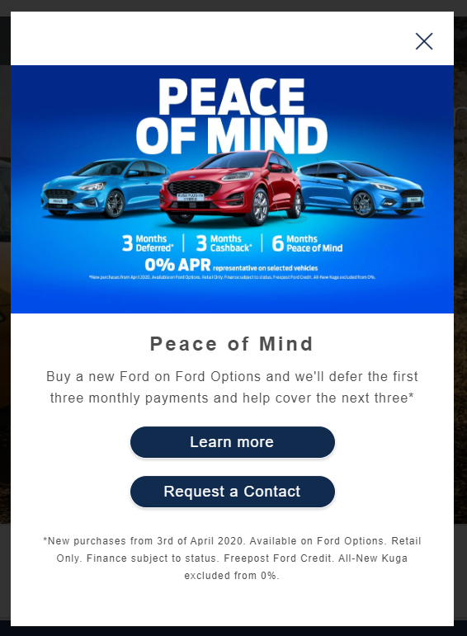

**Browser:**   
All  
  
**Device:**   
All  
  
**Audience rules:**   
All traffic

**QA Links:**

[**http://www.ford.co.uk/cars/new-fiesta?at_preview_token=olRYh4-O6mxPFbJDtMcPGA&at_preview_index=1_1&at_preview_listed_activities_only=true**](http://www.ford.co.uk/cars/new-fiesta?at_preview_token=olRYh4-O6mxPFbJDtMcPGA&at_preview_index=1_1&at_preview_listed_activities_only=true)